1. Install Jenkins and run Jenkins on port number 8081.
2. Install java 17 version → sudo dnf install -y java-17-amazon-corretto
3. Install jenkins → sudo yum install jenkins
4. sudo systemctl enable jenkins
5. sudo systemctl start jenkins
6. sudo systemctl status jenkins

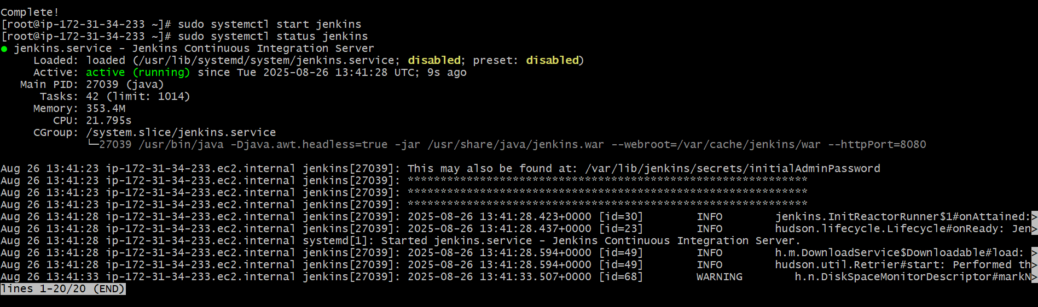

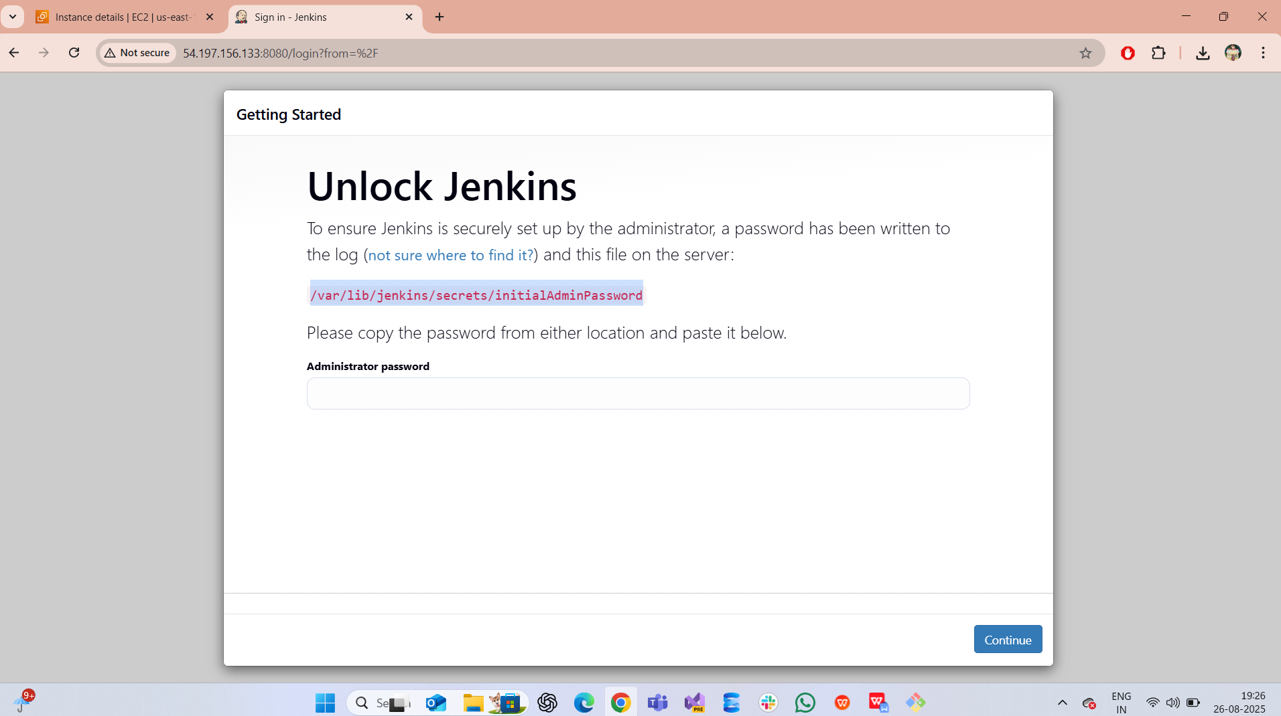

1. Now changing port number to 8081
2. Now go to → sudo vi /usr/lib/systemd/system/jenkins.service
3. Update → Environment="JENKINS_PORT=8081"
4. sudo systemctl daemon-reexec
5. sudo systemctl daemon-reload
6. sudo systemctl restart jenkins
7. Now check in browser public-ip-of-EC2:8081

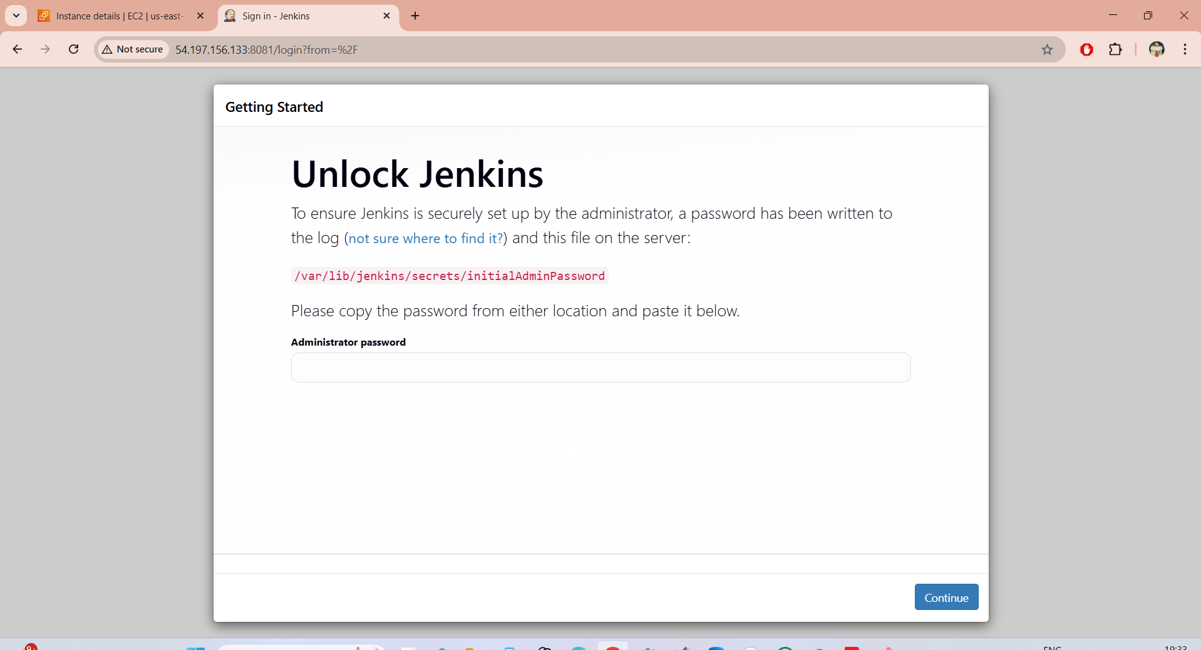

2) Secure Jenkins server

1. Check the password and login to jenkins → cd /var/lib/jenkins/secrets
2. Cat initialAdminPassword
3. Now login to jenkins

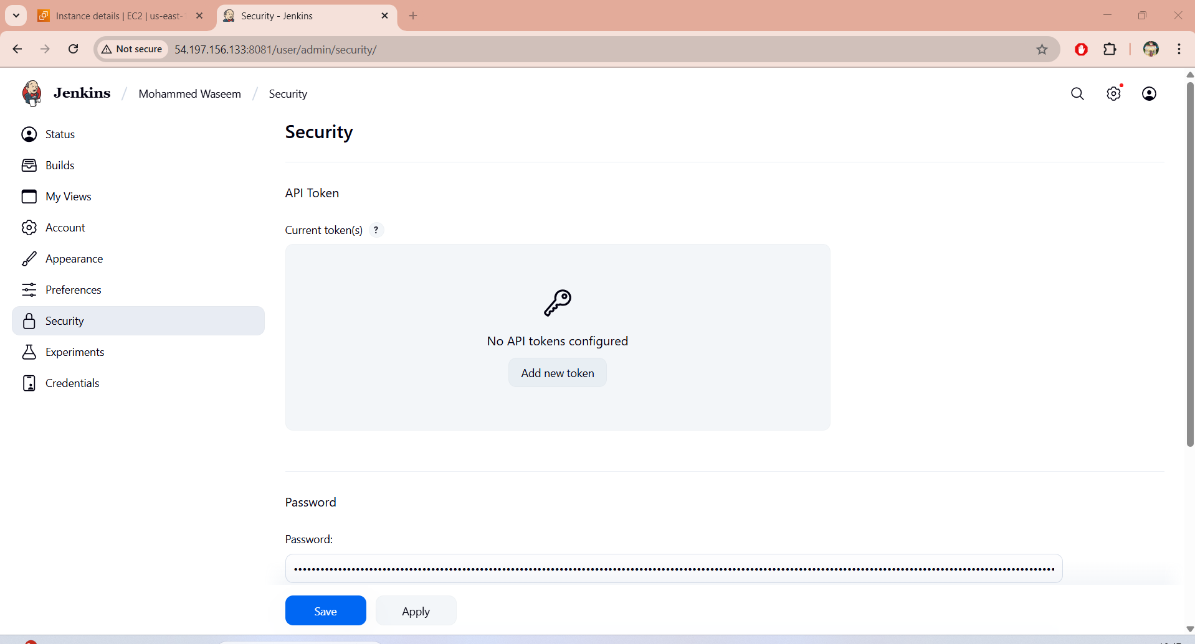

3) Create users called DevOps, Testing in Jenkins with Limited access.

1. Goto → manage jenkins → users then create devops and testing users

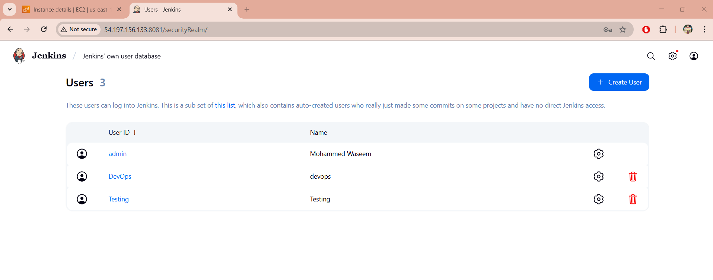

1. Now we have install plugins
2. Go to manage jenkins ---> plugins--> available plugins(Role based authorization stratergy)

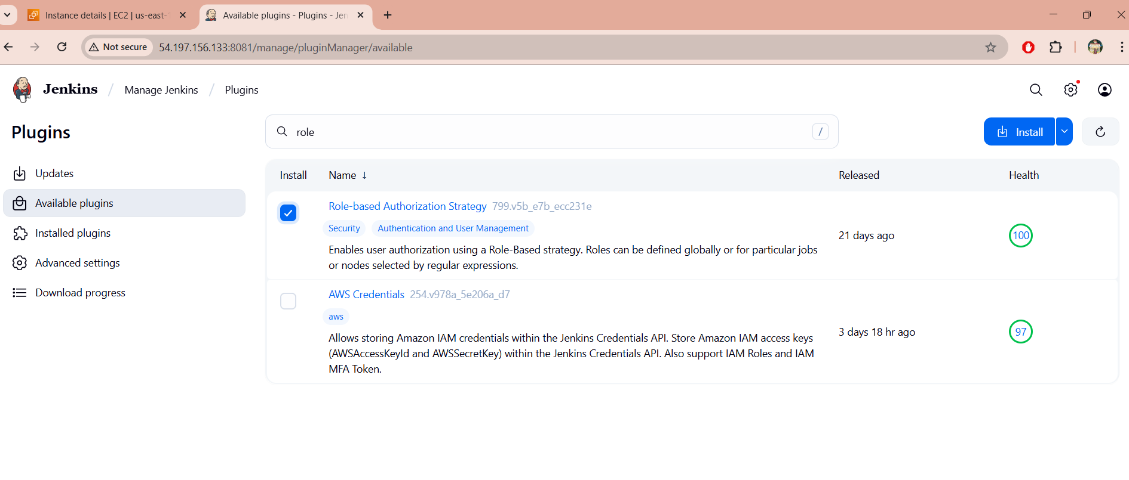

1. Here we have given permission to users
2. Go to manage jenkins--> security--> authorization dropdown select (Project based………!)

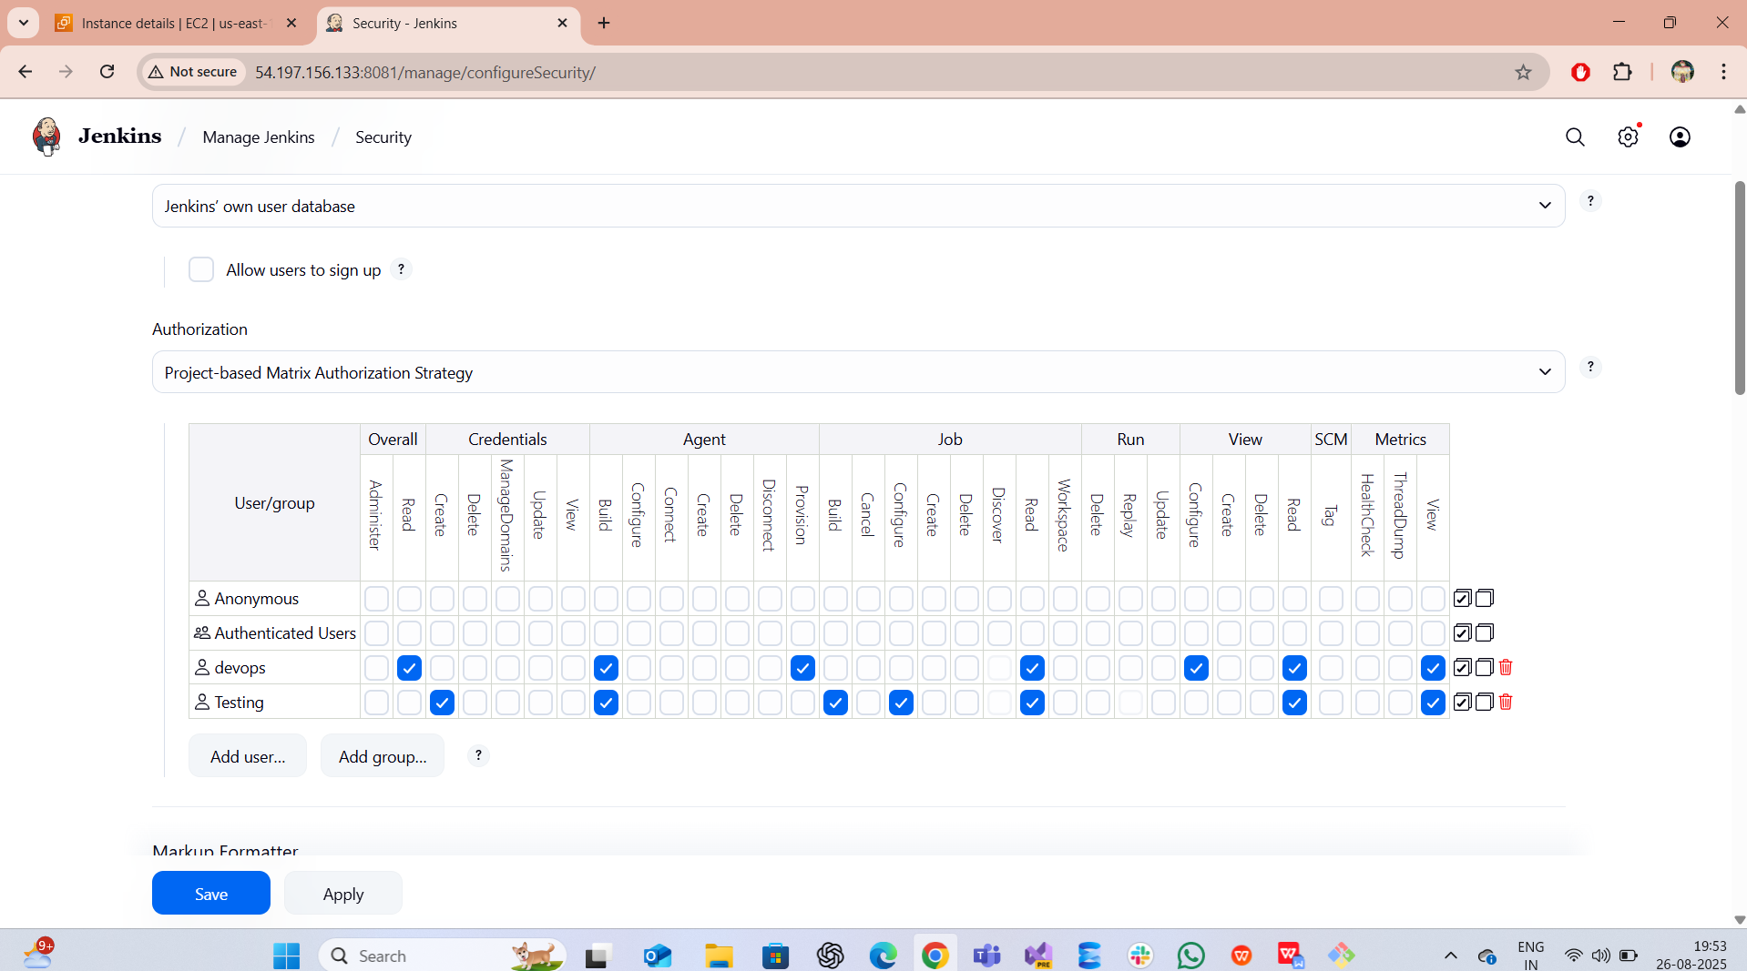

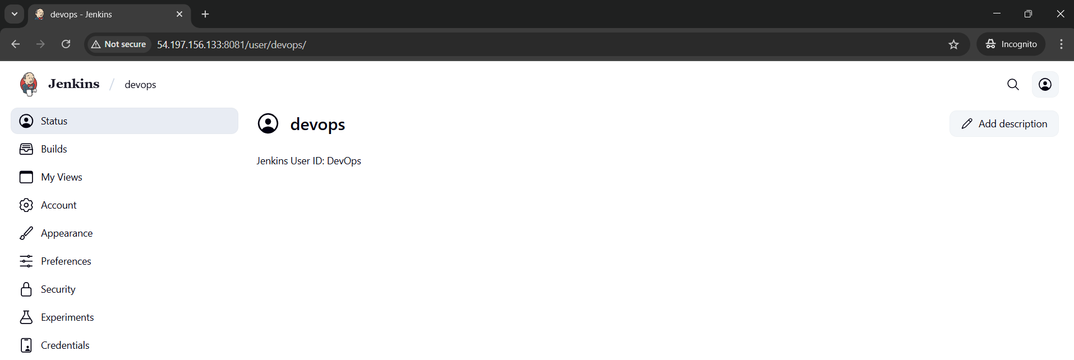

4) Configure labels and restrict the jobs to execute based on label only.

1. Manage jenkins → system → create label Master
2. To create job --> click on new item--> give job name-->select( freestyle project) and hit OK
3. Created first job having label Master
4. Create second job without label Master
5. Create third job without label Master
6. So here for only first got build with master label
7. And also we have installed git

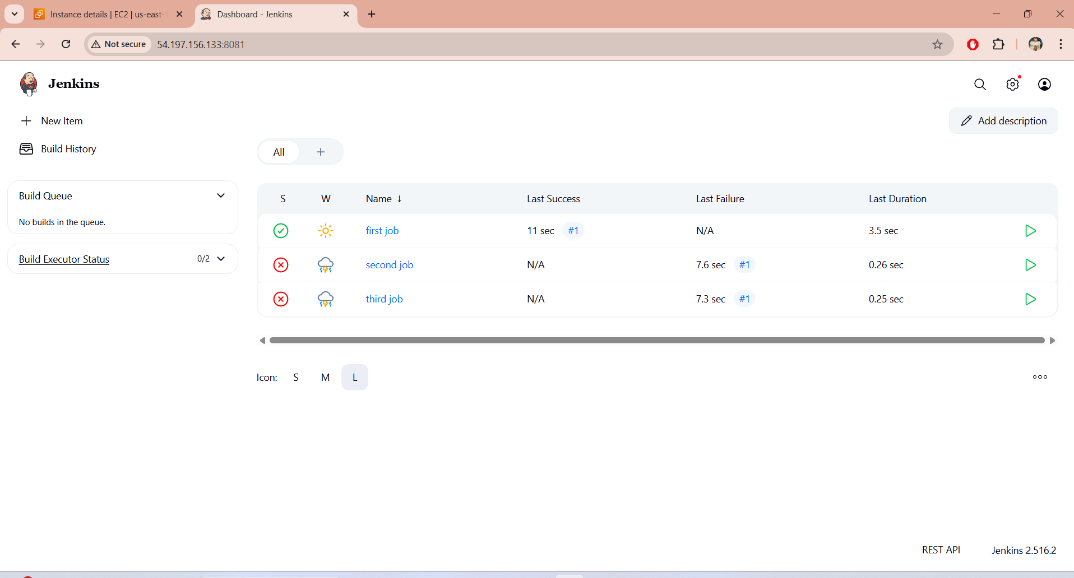



5) Create Three sample jobs using the below URL.  
   [https://github.com/betawins/Techie_horizon_Login_app.git](https://github.com/betawins/Techie_horizon_Login_app.git" \t "https://app.slack.com/client/T03TRQ064Q0/_blank)

1. Here we have created three jobs with lable (Master)
2. Than update the above url in Git repo
3. Did similar to other jobs

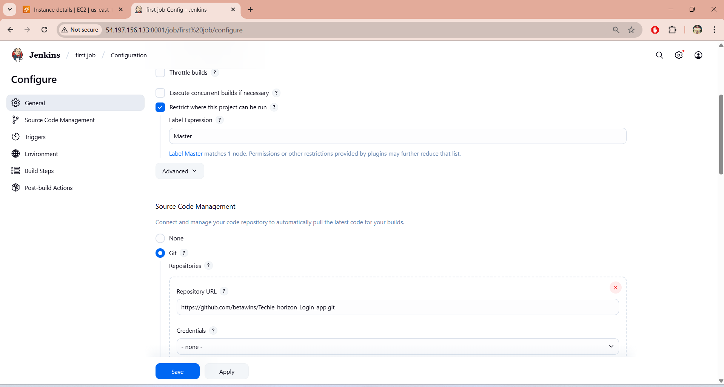

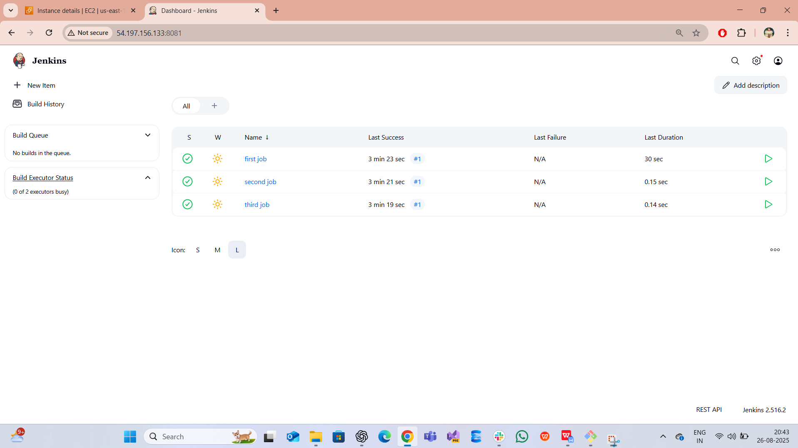

6) Create one Jenkins job using git hub Private repository

1. Goto → github → settings → developer settings → personal access token (pat) → fine-grained tokens → create new token as (vaseem-token)

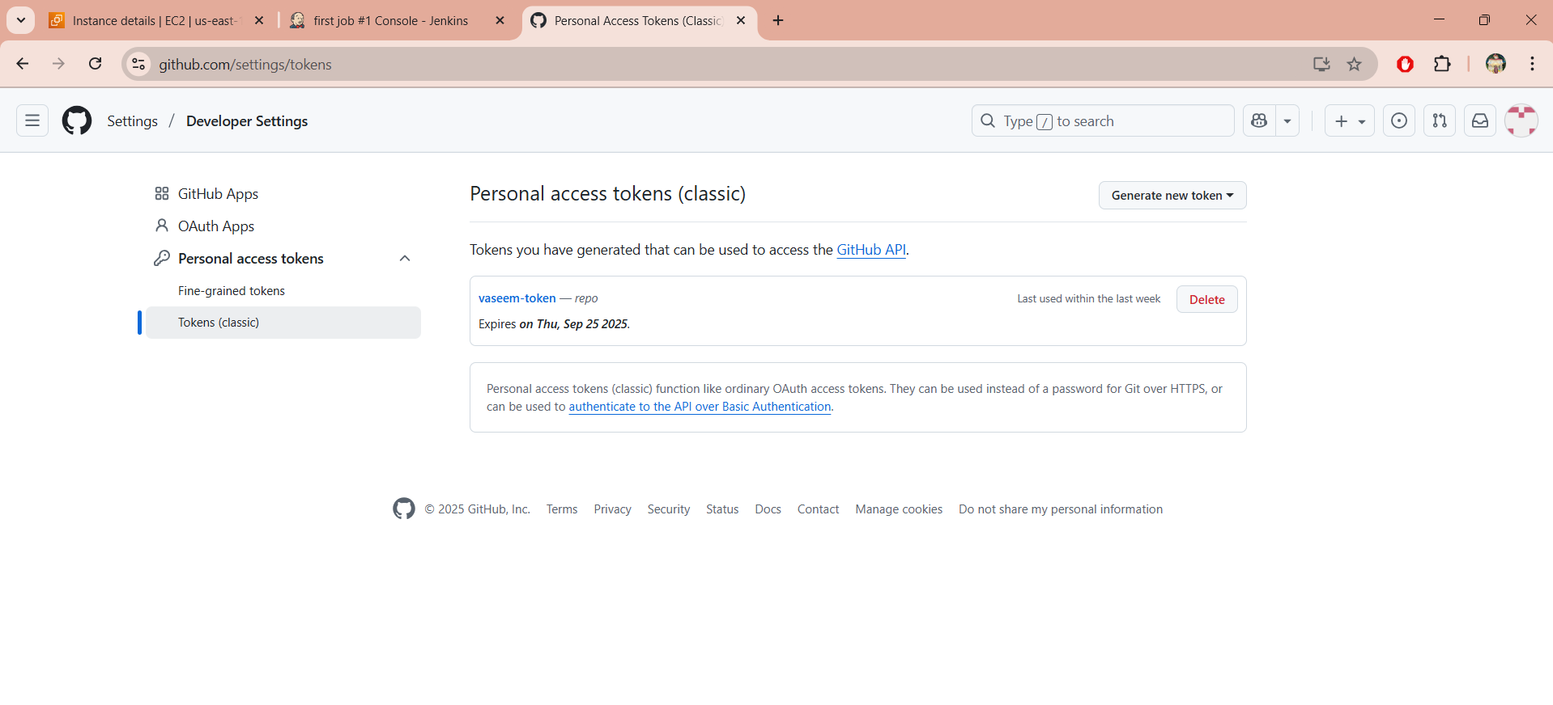

1. Go to manage jenkins-->credentials

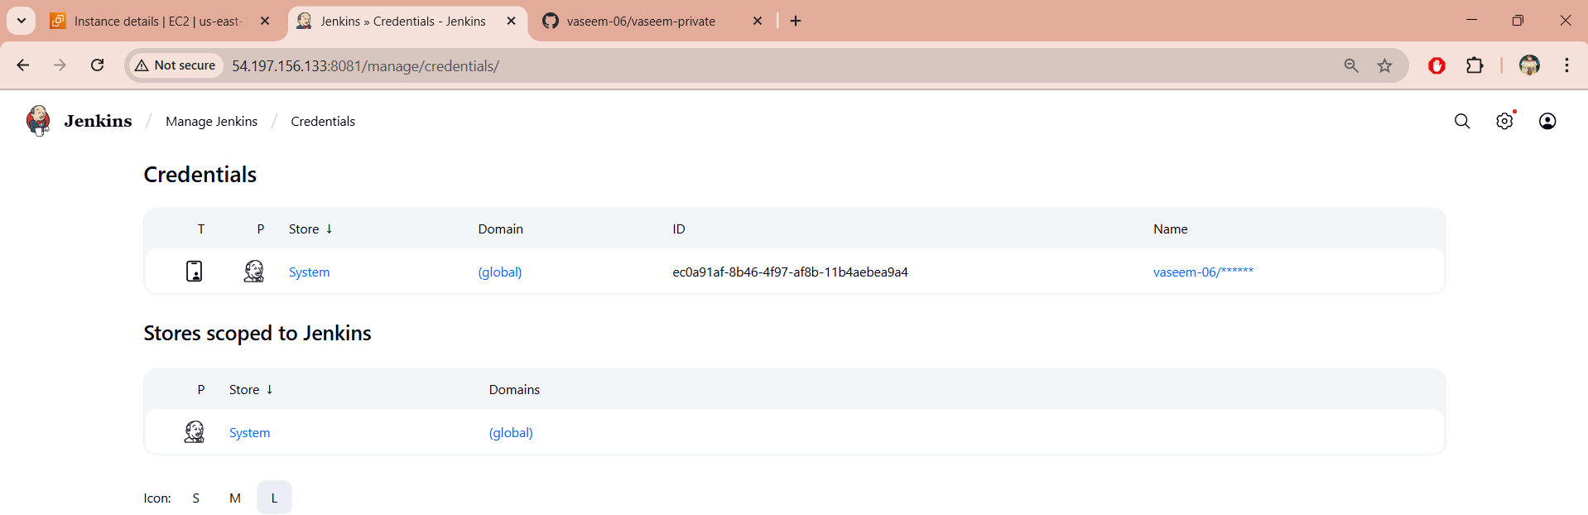

1. Here we have cretaed a new repo named as (vaseem-private)

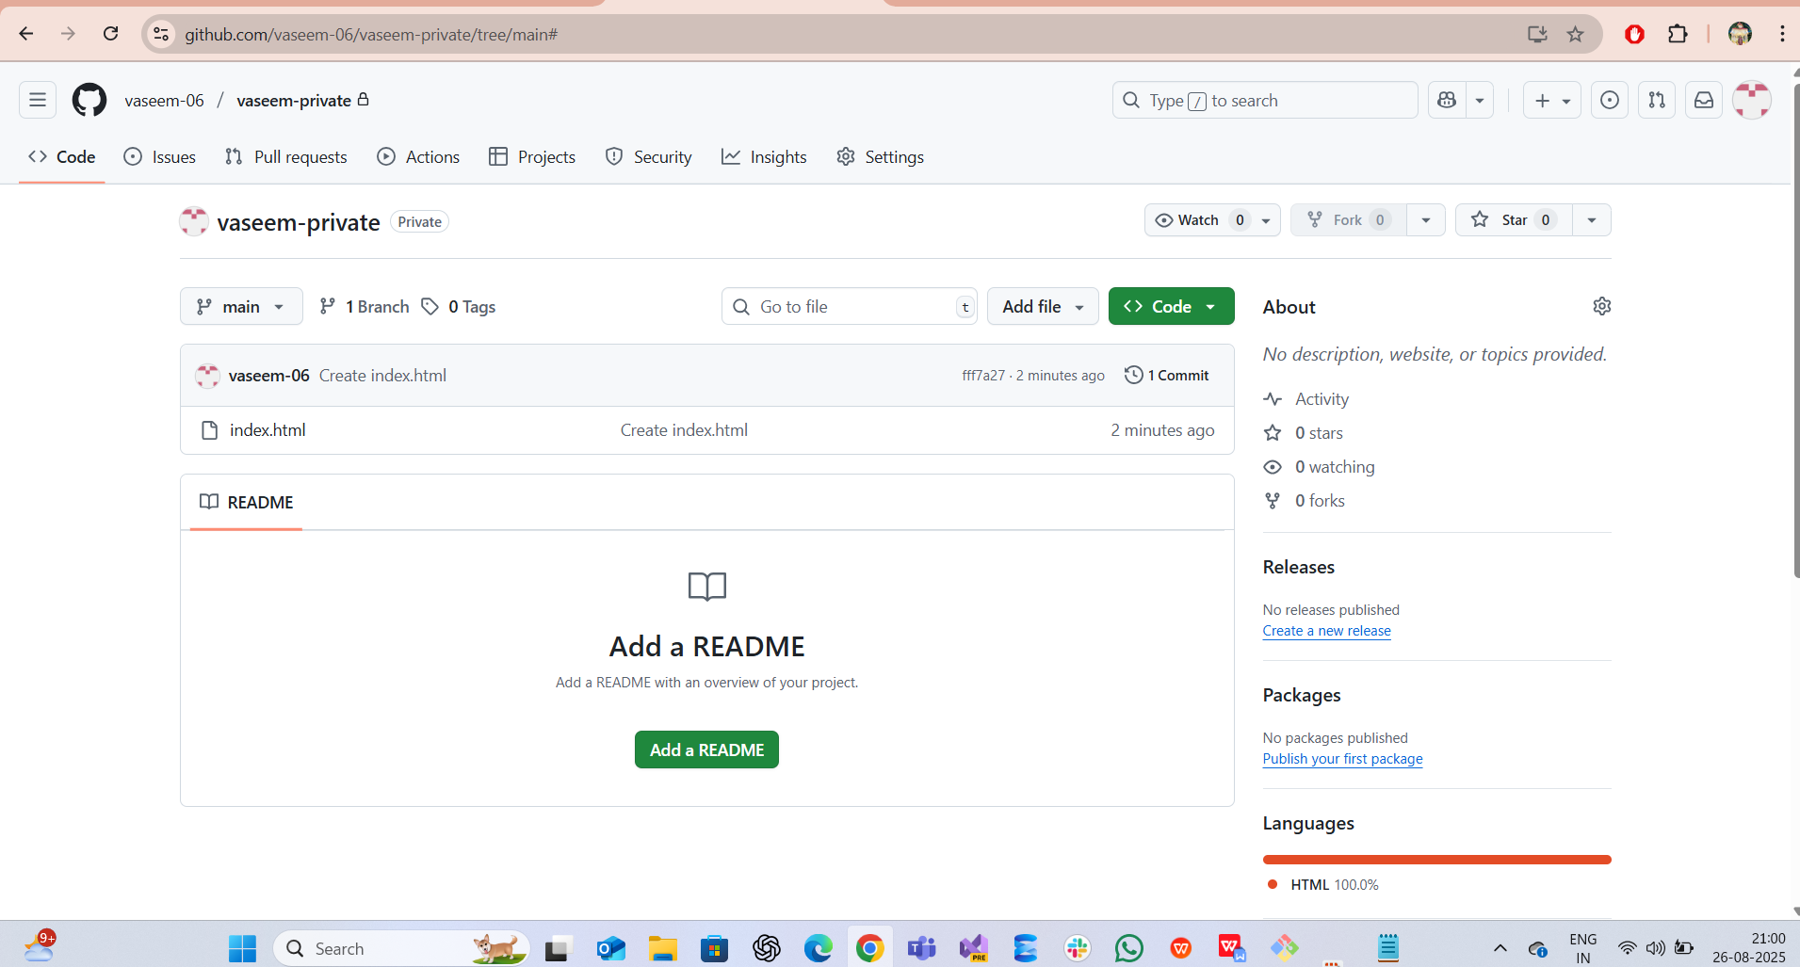

1. Here go to jenkins-->select job (second job)-->configure-->update url which we have created repo in main as vaseem-private-->credentials-->hit SAVE
2. Copy the PAT, github URL & add the credentials then configuration
3. Created label as main and update in lable abd url
4. Go to -->private job-->console output-->shows as SUCCESS

